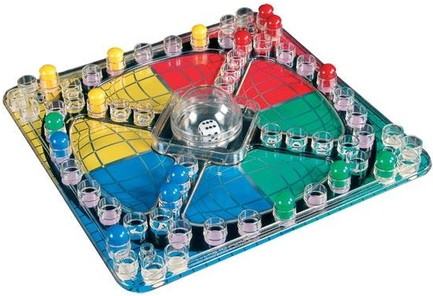  Frustration  A SOFTWARE ENGINEERING DESIGN PROJECT | assignment 2017: gROUP pROJECT  Part 2: User Interface  GROUP  Rubab Ramzan - S00162293  Brain Mc Gowan - S00165159  Bryan Kerruish - S00173160

Table of Contents
The users 2
Beginning a game 2
Rolling the dice 3
The first move 4
The last move 5
The end of the game 6

The users
Frustration is a family game for all ages and abilities. The game has a simple set of rules and virtual no learning curb.
We have aimed to make our interface as simple and intuitive to use as possible to facilitate all age categories and computer ability.

Beginning a game
The number of players is the only requirement in setting up a game. To make this as simple as possible, the number of players’ choice is visually represented with the game pieces.

Rolling the dice
When a player needs to roll the dice, a dialog with the players coloured piece and a die is displayed. When the dice is clicked, the dice roll is animated and the player is shown the board.

The first move
The first move onto the board will always be as a six. In the above screen, red has rolled a six, all four red pieces are currently “home” and are highlighted. The player can click any of the four red pieces and it will move to the highlighted red “start position”.
The interface also has three areas below the board with the game information.
The left side contains the game log. This will display a log of all the rolls, moves and actions of the game.
The centre contains the dice result.
The right side contains the current player.

The last move
The game will end when a player moves all his pieces’ home. In the above screen, the green player has rolled a three and is able to move his final piece home.

The end of the game
When the game ends, the game log will display the winner highlighted in that players colour. The centre information pane will display the winner and trophy. The left pane will provide the option to start a new game.
If new game is selected, we restart from the beginning.

